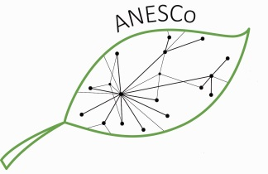 | Alumni Project Seminar APPLICATION FORM

“Making our Food Sustainable”, 24. June – 02. July 2022, Siegen/Bonn (Germany)
First name:
Surname:
Nationality:
Gender:
Date of birth:
Current Profession:
German University:
Master programme:
Study period:
Corresponding Address:

Expected travel costs:  (select a cheap connection) | Flight costs:
 | Costs for train/bus:
Phone number:
E-mail:

Please append to this form:

(1) a short motivation letter which includes a description of your relation with and your expertise of “sustainable food supply and climate protection” (1/2 page), (2) Curriculum vitae (1 page), (3) short description of an already existing climate protection project for the ANESCo crowd-funding campaign (ca. 1-2 pages, see announcement for details).

Please do not forget to specify the expected travel costs by selecting cheap opportunities !

PLEASE, SEND THE COMPLETED APPLICATION FORM, MOTIVATION LETTER AND CV AS WORD FILES !
Please send all documents via e-mail until March 10th 2022 to: tiemo@uni-greifswald.de.
Applicants of the STUBE network are requested to apply via: stube@dwbo.de

Submission Deadline: March 10, 2022 Decision: until March 23, 2022

