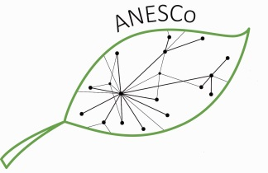 | Alumni Project Seminar APPLICATION FORM

Eco-Tourism and Sustainable Development, Nepal, October 7 – 17, 2017
First name:
Surname:
Nationality:
Gender:
Date of birth:
Current Profession:
German University:
Master programme:
Study period:
Corresponding Address:

Expected travel costs:  (select a cheap connection) | Flight costs: Costs for train/bus:
Phone number:
E-mail:
Working Group Preference | My 1st preference: My 2nd preference:
Working Groups: (1) touristic infrastructure development, (2) community involvement and local economies (participation, acceptance), (3) protected area management, (4) tourism carbon footprint and compensation opportunities, (5) school partnership & environmental education, (6) research.

Please append to this form: Motivation letter with photo (1 page), Curriculum vitae (1 page)

Please do not forget to specify the expected travel costs by selecting cheap opportunities !

PLEASE, SEND THE COMPLETED APPLICATION FORM, MOTIVATION LETTER AN CV AS WORD FILES (!)

to: tiemo@uni-greifswald.de

Submission Deadline: 1st June, 2017 Decision: 13thJune, 2017

